**Important dates**

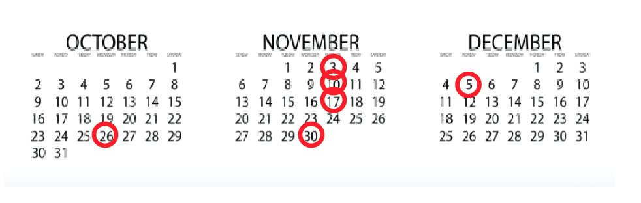

Friday 10/21 - Meeting at 4 dope

Wednesday 10/26 - Project design submission due ay!! Quan Le reply to this.

According to the syllabus:

Thursday 11/3 11 pm Proj high-reliability design due

Thursday 11/10 11 pm Proj component implementation due

Thursday 11/17 11 pm Proj system integration due

11/30 2 pm Proj acceptance testing due

12/5 2 pm Proj final version due